16). Demonstrate Infrastructure as a Service (IaaS) by creating a resources group using a Public Cloud Service Provider (Azure), configure with minimum CPU, RAM, and Storage.

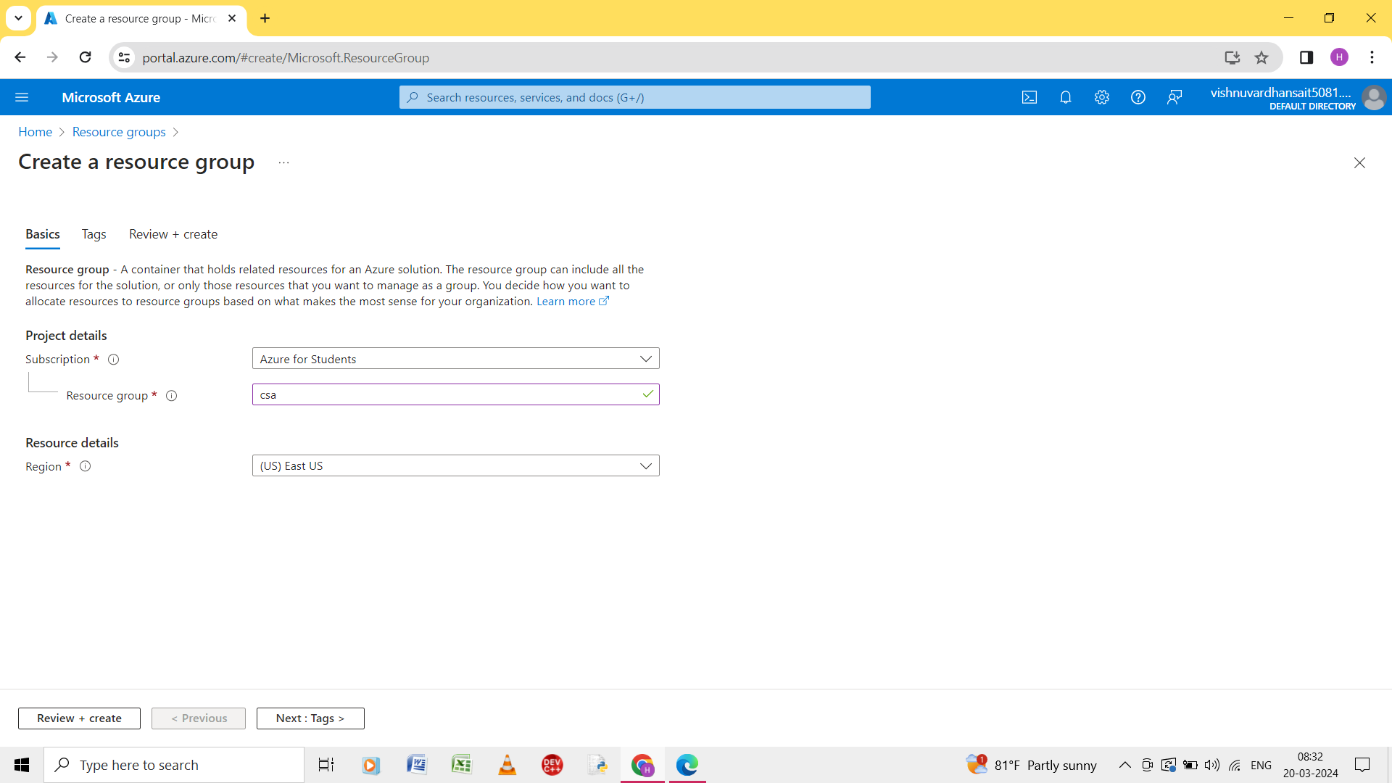

Step 1: create the resource it contains three steps.

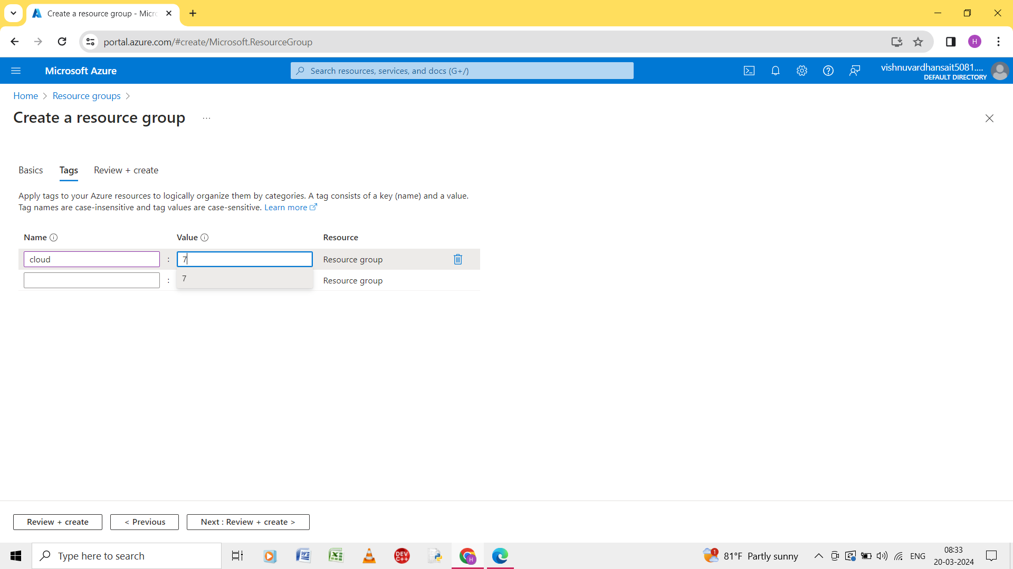

Step 2: give the details of the basic, tags, and review and create.

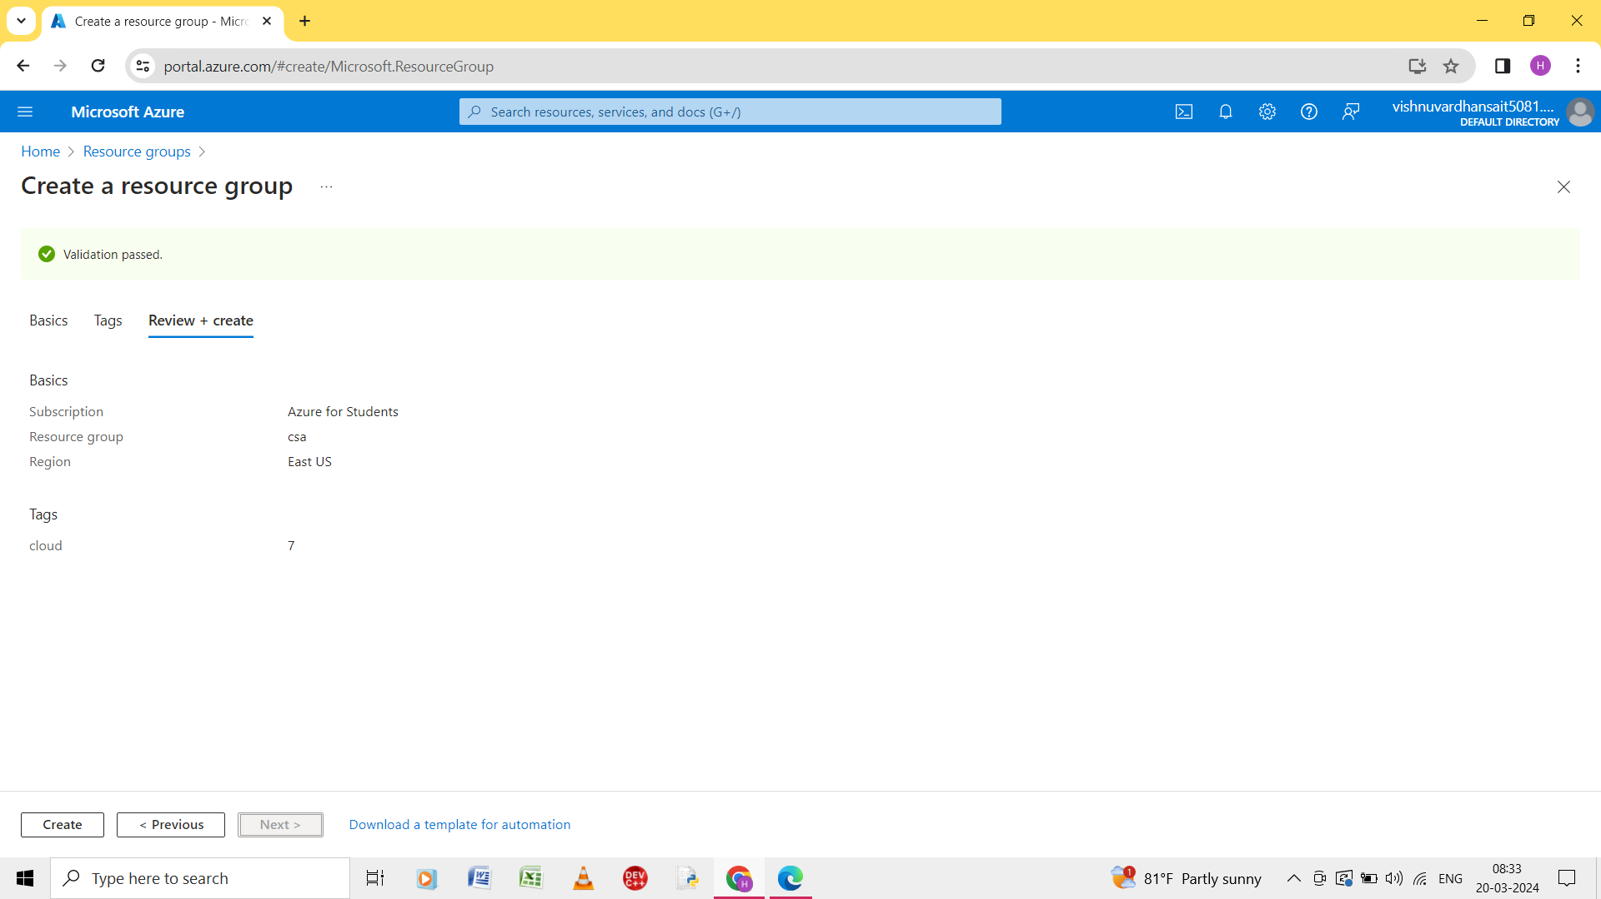

Step 3: And it gives the validation passed.

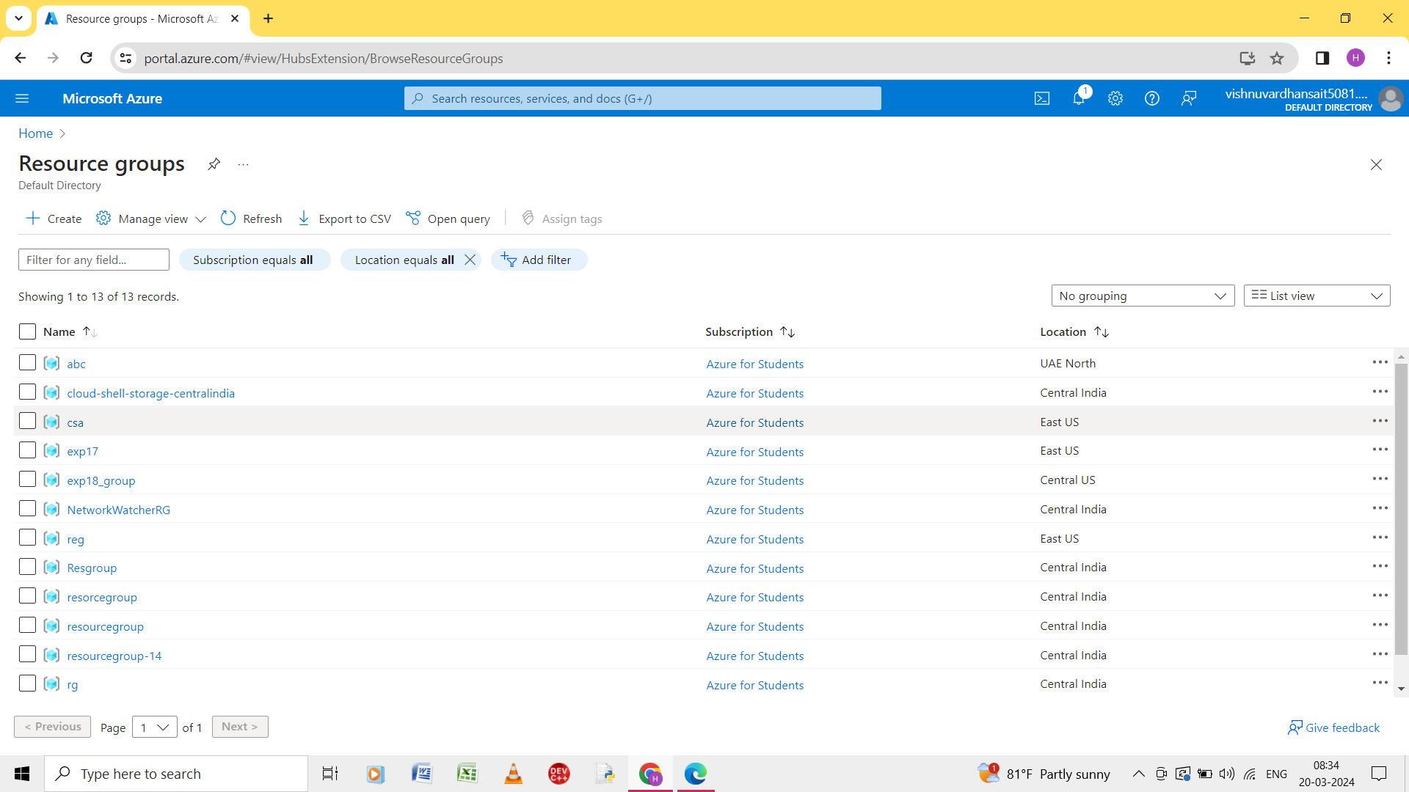

Step 4: the resource group created in the home page.